Subject: Confirmation and Acceptance of Quoted Prices
Dear Mapaseka,
We acknowledge receipt of your correspondence regarding the project pricing.
We hereby confirm and accept that we will be able to deliver the project in accordance with the quoted amounts. Our team remains committed to ensuring the successful execution and timely completion of the project as per the agreed terms.
Please advise should any further formal documentation or confirmation be required to proceed.
Kind regards,
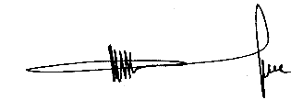
Muzi Lukhele
Managing Director

